**ME 111**

**Projection of Solids**

|  |  |  |
| --- | --- | --- |
| 1 | A cylinder 40 mm diameter and 50 mm axis is resting on one point of a base circle on VP while it’s axis makes 450 with VP and FV of the axis 350 with HP. Draw projections. | 30 |
| 2 | Draw the top and front views of a rectangular pyramid of sides of base 40x 50 mm and height 70 mm when it lies on one of its larger triangular faces on HP.  The longer edge of the base of the triangular face lying on HP is inclined at 600 to VP in the top view with the apex of the pyramid  being nearer to VP. | 35 |
| 3 | A cone of base 80 mm diameter and height 100 mm lies with one of its generators on HP and the axis appears to be inclined to VP at an angle of 400 in the top view.  Draw its top and front views. | 35 |

**Solution**

**1**

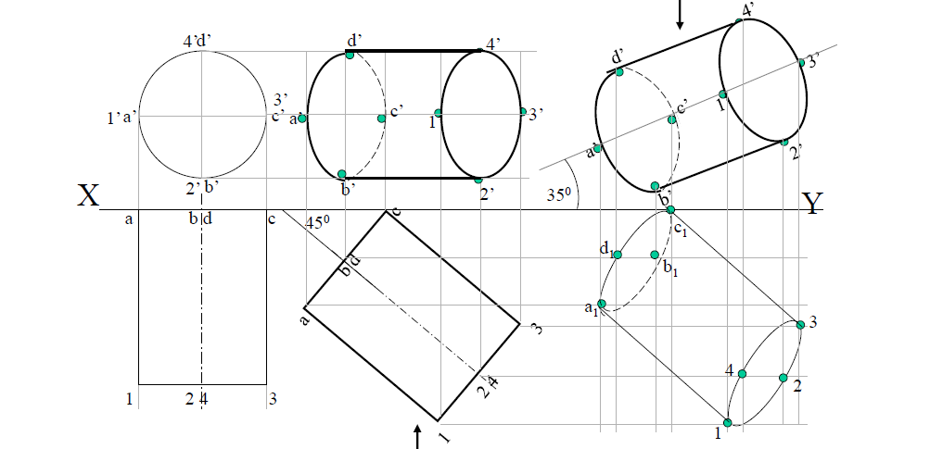

**2**

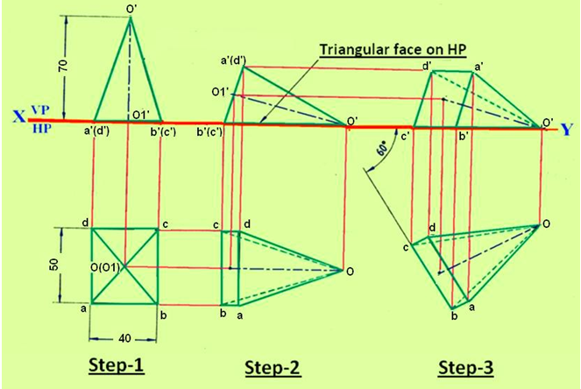

**3**

